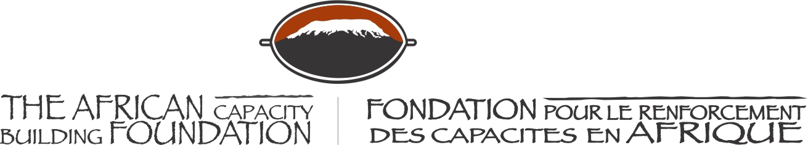

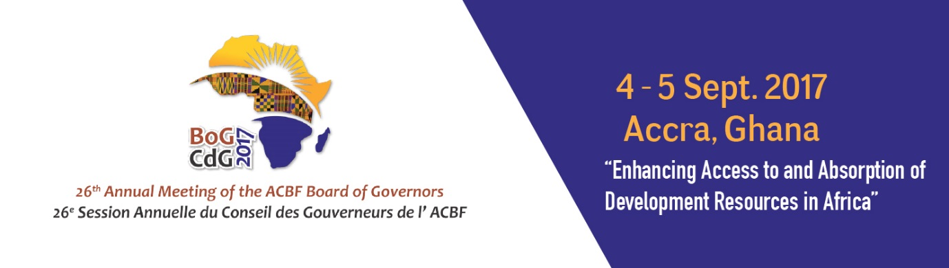

26th ANNUAL MEETING OF THE BOARD OF GOVERNORS OF THE AFRICAN CAPACITY BUILDING FOUNDATION

4-5 September 2017

MÖVENPICK AMBASSADOR HOTEL
Accra, Ghana

Keynote address
H.E. Quartey Thomas Kwesi, Deputy Chairperson of the African Union Commission

The African Capacity Building Foundation: 2 Fairbairn Drive, Mount Pleasant, Harare, Zimbabwe; Tel: +2634304649.
Email: root@acbf-pact.org. Website: www.acbf-pact.org

Key messages
- Capacity remains important for Africa’s future and the leaders of the continent must invest and support the various interventions. It is in recognition of the role of ACBF and capacity development that the Foundation has been granted the status of Specialized Agency.
- The important theme of the 26th ACBF Board of Governors Meeting on “Accessing Funds for Development: Required Capacities for Resource Mobilization, Utilization and Absorption” is to be situated in the broad and important framework of building the required capacities for Africa to achieve the goals set in Agenda 2063.
- For capacities to be build, all countries and stakeholders should join forces in providing the necessary political and financial support to capacity building institutions such as ACBF.
- The African Union Commission (AUC) will continue to provide the required support to ACBF.

Hon. Yaw Osafo-Maafo, Senior Minister, Republic of Ghana;
Honorable Goodall Gondwe, Chair of ACBF Board of Governors;
Mr Erastus Mwencha, Chair of the Executive Board of ACBF;
Distinguished Members of the ACBF Board of Governors & Executive Board;
Prof Emmanuel Nnadozie, Executive Secretary of the ACBF
Top Government officials from Ghana;
Top Government officials from other countries;
Members of the Diplomatic Corp;
Representatives of development partners;
Distinguished panelists and experts;
Members of the media;
Dear friends;
Ladies and gentlemen;

Good morning!

Let me first of all take this opportunity to express my sincere thanks and appreciation to the African Capacity Building Foundation (ACBF), all its Board of Governors, and Executive Board members and its dedicated and very professional staff for organizing this event, which certainly is timely.

I am honored to join you here today in this beautiful and historic city of Accra for the 26th Board of Governors Meeting of ACBF. I would like to also commend the Government of Ghana for accepting to host and supporting the organization of this very important Meeting.

This 26th Board of Governors Meeting of ACBF is taking place during the year that the African Union has decided to endorse ACBF as its Specialized Agency for Capacity Development in Africa. We expect to see concrete outcomes and advancements for capacity development in Africa. However, I must quickly confess that we should not leave all to ACBF. Unless we all, governments, development partners and key stakeholders, provide the necessary support to the Foundation, those outcomes will only remain a dream.

Distinguished Ladies and gentlemen;
ACBF has been granted the status of Specialized Agency not just because we like ACBF nor that we simply needed to add to the list of specialized agencies to expand the AU Empire. Rather, it is solely in recognition of the criticality of capacity development on the continent and the uncontested role and vast experience of ACBF in this area.

You are certainly aware that ACBF has advised and supported African countries in the past 26 years on the decisive steps to take to develop the key institutions and the practical skills urgently required for the continent’s economic transformation. Moreover and more specifically, the role of ACBF in contributing to the successful implementation of Agenda 2063 cannot be overemphasized. Studies such as the Capacity Requirements for Agenda 2063 and the African Critical Technical Skills, have helped understand how and where to build the capacities if we are to achieve the targets set in our long term development blueprint.

Another work done by ACBF which I found very useful is the Digest of OAU-AU Treaties, Conventions and Agreements from 1963 to 2014. The study shows that there are quite a number of treaties and conventions signed but implementation is indeed a big challenge. Capacity for implementation is therefore a quite worrisome issue. Efforts must be put on implementation now! Africa will rise and sustain only if the required institutional and human capacities are built and capacity brought at the center of the development discourse and programs. Capacity remains important for Africa’s future and the leaders of the continent must invest and support the various interventions if our continent is to advance. It is Governors and development partners like you who can, and will, make that happen.

Dear friends;
We, at the African Union Commission, value the role and support provided by ACBF to our institution. Among them has been the African Union Capacity Building Project (AU-CAP). This particular intervention by ACBF aims at supporting the institutional transformation processes of the Commission and providing targeted capacity building support to facilitate the implementation of the priority thematic programs of the Commission approved by the policy organs of the African Union.

The ACBF-supported program has contributed to the institutional enhancement of the African Union, particularly in the areas of strategic planning and integrated internal coordination processes. Through ACBF support, we have been able to organize a series of technical consultation meetings and forums with AU Organs and Regional Economic Communities (RECs) aimed at validating the AU Agenda 2063 and aligning it to the strategic plans of the different Organs and RECs.

Some of the tangible achievements in 2015-2016 include the following: the Regional Training Workshops on best practices in Project Management, Private Public Partnerships and Microfinance targeted at Women and Youth; the Regional Forum on Trade facilitation; the 8th African Private Sector Forum for youth and women (over 100 participants including 56 females); the Training on Result Based Management and Planning, Monitoring and Evaluation for the African Union Commission (AUC) and its organs and Regional Offices; inter alia.

More recently, ACBF has supported the AUC in the preparation of the AUC-China Capacity Development Program. The Program is within the framework of the Forum on China-Africa Cooperation (FOCAC) and is designed to address capacity challenges in priority areas identified in FOCAC and the 10 years implementation plan of Agenda 2063. I could go on and on with what ACBF is delivering for the continent.

Distinguished Ladies and gentlemen;
This 26th Annual Meeting of the Board of Governors of ACBF is taking place at a historic period. This is a watershed year for Africa, which is now in the process of implementing the “Financing of the Union”. This is indeed a historic decision adopted by Heads of State and Government (HOSG) in a “Retreat on Financing of the Union” during the 27th African Union Summit held in Kigali, Rwanda in July 2016. The Decision directs all African Union Member States to implement a 0.2 percent levy on eligible imports in order to finance the African Union.

This Meeting of ministers, experts and development specialists on the theme “Enhancing Access to and Absorption of Development Resources in Africa” is therefore very timely and appropriate. This ACBF Board of Governors Meeting shall thus provide us with opportunities to take stock of the key milestones of the past decades on development finance and to project for the future the kind of capacities required. We will have to seriously reflect on how well we have been able to capture, efficiently allocate and successfully absorb the available resources for development.

As we project into the next 6-7 years i.e. by 2023 (end of the First Ten Year Implementation Plan for Agenda 2063), will our narrative still be lack of domestic resources for own development, lack of absorption capacity, lack of bankable projects, or we would have built enough human and financial resources to ensure the socio-economic transformation of our beloved continent? I hope that the participants at this very important gathering will take time to reflect on where we want to be in the next decade.

Excellences, Distinguished Guests

It is in this context that we should situate access to funds for development in the broad and important framework of building the required capacities. All experts agree that capacity building is a complex and very long-term endeavour. ACBF has been in the field for the past 26 years and has demonstrated impressive and very satisfactory results. The journey is still long and we all have a role to play.

Here is my plea to you all present here. ACBF needs your commitment and political as well as financial support today more than ever. I am urging all African countries, development partners, and non-African members and friends to support ACBF and channel all capacity development related support through our Specialized Technical Agency for better coordination, efficiency, impact, and tangible results. ACBF knows what, where, when, and how to do it when it comes to capacity issues. The African Union and its organs are still committed and will continue to provide the required support for ACBF to better serve our continent.

In conclusion, Ladies and Gentlemen, let me end by once again expressing the appreciation of the African Union Commission to ACBF, its Board members, and all its staff as well as the Government of Ghana for the very well-organized event. I have no doubt that all the expertise gathered in this room will contribute to the quality of outcomes from this Meeting.

As the ACBF Board Chair, Hon. Goodall Gondwe rightly pointed out, let us join hands to build the Africa capable of achieving its own development!

I wish you all fruitful deliberations and I thank you for your attention.

Accra (Ghana)
September 4, 2017

H.E. Quartey Thomas Kwesi,
Deputy Chairperson of the African Union Commission

