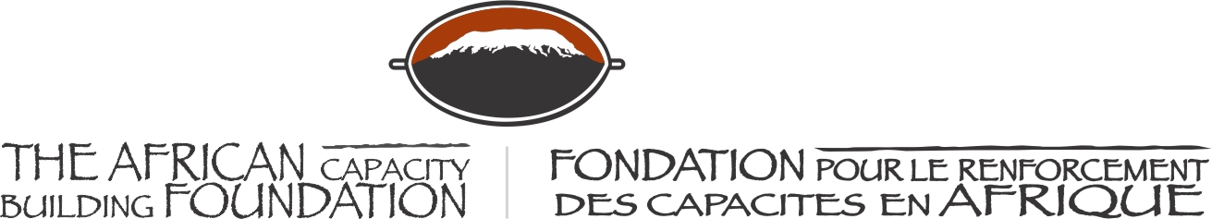

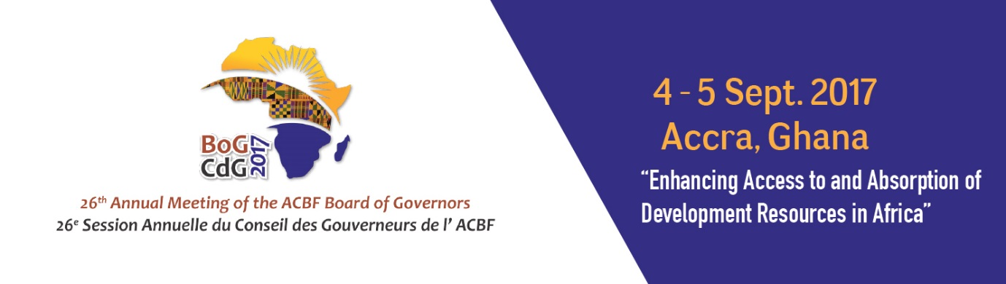

26th ANNUAL MEETING OF THE BOARD OF GOVERNORS OF THE AFRICAN CAPACITY BUILDING FOUNDATION

4-5 September 2017

MÖVENPICK AMBASSADOR HOTEL
Accra, Ghana

Official Opening Remarks
Hon. Yaw Osafo-Maafo,
Senior Minister, Republic of Ghana

The African Capacity Building Foundation: 2 Fairbairn Drive, Mount Pleasant, Harare, Zimbabwe; Tel: +2634304649.
Email: root@acbf-pact.org. Website: www.acbf-pact.org

Key messages
- Capacity remains binding constraint in implementation of Agenda 2063 and Agenda 2030. Africa socio-economic transformation will not ne achieved if this challenge is not addressed.
- Ghana appreciates ACBF’s support over the years not just for Ghana but across Africa and cherishes its long-standing partnership with ACBF. It will hence continue to provide the required support for the Foundation to better play its role as coordinator of capacity development interventions in Africa.
- Making a call for support and resources (political and financial) from other African Governments and cooperating partners towards ACBF as the AU’s specialised agency tasked with coordinating capacity development in Africa.

H.E. Quartey Thomas Kwesi, Deputy Chairperson of the African Union Commission;
Honorable Goodall Gondwe, Chair of ACBF Board of Governors;
Mr Erastus Mwencha, Chair of ACBF Executive Board;
Distinguished Members of the ACBF Board of Governors & Executive Board;
Prof Emmanuel Nnadozie, Executive Secretary of the ACBF
Top Government officials from Ghana;
Top Government officials from other countries;
Members of the Diplomatic Corp;
Representatives of development partners;
Distinguished panelists and experts;
Members of the media;
Dear friends;
Ladies and gentlemen;

It gives me great pleasure indeed to welcome you all to the 26th Board of Governors Meeting of the African Capacity Building Foundation (ACBF) on the theme “Enhancing Access to and Absorption of Development Resources in Africa”

I would like to extend a very special welcome to our international guests especially if this is the first time you are coming to Ghana. It is my sincere hope that we shall be seeing more of you in the future when you will be coming perhaps in a private capacity and as we move toward a truly integrated continent. I want to thank ACBF for convening this Meeting here in Accra.

Distinguished Ladies and gentlemen;

My starting point today is the proverb which says “a monkey who tried to get three mangoes from three different branches in a tree at the same time fell on its back”. This is to confess that the key issue which needs special attention is capacity. Tackling this challenge is crucial if we want to ensure that Africa achieves its socio-economic transformation and be a global player today. If we lose the battle of capacity building, we lose the whole war of socio-economic development.

We, in Ghana, have understood this long time ago and have since partnered with ACBF since 1993 to ensure that we tackle the most critical capacity gaps – with satisfying dividends. Allow me to share some few achievements.

The Institute for Democratic Governance (IDEG), has with ACBF’s support, evolved as a stellar think-tank on issues of good governance and democracy. IDEG has influenced and championed a number of strategic interface between state and non-state actors in Ghana. The ACBF support to IDEG included strengthening of the governance arrangements, financial management, and procurement as well as monitoring and evaluation. Through ACBF’s support the Institute has developed robust operational modalities and engagement strategies that have enabled the institutions to attract numerous local and international partnerships. IDEG has emerged as a highly respected policy think tank with strong advocacy capabilities and strong convening powers. The Institute has managed to create a brand that is highly recognized both in the country and globally. IDEG was instrumental in the signing of the Kumasi Peace Pact, a declaration that helped to mitigate the threat of widespread political violence during the 2012 Presidential elections.

The second example I would like to give is that of the training program, namely the Ghana Institute of Management and Public Administration (GIMPA). The training program also supported by ACBF has provided hands-on skills and competencies to a number of senior level public servants in Ghana.

Additionally, the Foundation’s support has been critical to the establishment and sustained growth of the sub-regional Masters of Economic Policy Management Degree Program (EPM) and the Public Sector Management Training Program (PSMTP). The EPM has matured into a dominant program in the Economic Faculty of the University of Ghana. More than 775 public sector managers have benefited (graduated) from the program via ACBF sponsorship. Moreover, beyond Ghana, 359 middle level public sector officials from the sub-region (Nigeria, Sierra Leone, Liberia and The Gambia) have directly benefitted from ACBFs Scholarship under the PSTMP at GIMPA with other sub-regional public administration training institutes. I am telling the success of other countries to just highlight that all African countries can and should tell the story of how ACBF has supported them. I am sure you all have testimonies.

Distinguished Ladies and Gentlemen;

Among the good work done by ACBF are the production and the dissemination of fit-for-purpose and relevant knowledge. ACBF’s 2015 flagship, the Africa Capacity Report, focused on the pertinent issue of Domestic Resource Mobilization. This is a timely contribution as it came when we were all thinking about what do and what capacities to build in order to efficiently mobilize internal resources for our own national development agendas.

Today again, you will agree with me that the theme of this Board of Governors Meeting is extremely compelling. This well-thought out theme, speaks to issues that we should collectively focus on in realizing a stronger African Agenda and achieve the socio-economic transformation of our continent.

This agenda should speak to the critical issues facing the continent when it comes to accessing the resources allocated to development. If we know where the resources are, then not accessing them is a real and basic capacity issue. If we are able to access the resources, but not being able to efficiently allocate them to the economically and socially productive sectors is also a real and basic capacity issue. If we manage to mobilize the required resources for development, then not being able to absorb them remains again a real and basic capacity issue.

Distinguished Ladies and gentlemen;

Together we are all faced with the challenge of defeating the capacity challenges that, as we speak, condemn all our countries to the conditions of developing economies when we have the richest continent – youthful population and abundant natural resources. What is the real problem then? Experts like those from ACBF should tell us and we will listen. But for some of us the key question to answer is around “how to do things.” This is a capacity-related question which we are ready to put our political and financial resources is ACBF can help us address.

This is a call to ACBF and all development partners and experts present here to pay attention to what is referred in the literature as the “know-do” gap. Beyond this gathering, the issue of producing, sharing and translation of research evidence or knowledge into skills represents an important exercise to be conducted. In the strategic document produced by ACBF on the Capacity Requirements for Agenda 2063, some of these important questions were raised: what curriculums should African universities emphasize and how to provide the requisite skills required for the continent’s transformation agenda? How can academia effectively partner with private firms to provide the required skills? How to encourage rural youth as well as women to actively participate in the implementation and delivery of the continental agendas?

ACBF is asking the right questions and, as stipulated in its Strategy 2017-2021, should put together more knowledge on what works while providing technical advice on “how to do things.”

Ghana welcomes the decision of the African heads of state and Government to designate ACBF as a Specialized Agency for Capacity Building in Africa which in my view is a huge responsibility placed on ACBF. Let us therefore support our ACBF to deliver on this new and important mandate.

Distinguished Ladies and gentlemen;

To conclude, allow me to use another proverb which says that “when spider webs unite, they can tie up a lion.” This is to emphasize on the importance of unity and collaboration in tackling the capacity challenges faced by our African countries. Believe me, we can address problems together, no matter how big.

To tackle our capacity issues, I am again urging you all to provide the necessary support to capacity building institutions such as ACBF which have the mandate and experience to coordinate capacity building interventions in Africa. I am calling on all Ministers and development partners to financially and politically support ACBF for it to better play its role. I can assure you that Ghana has already made its pledge towards ACBF’s 2017-2021 Strategy and has paid its dues for 2017. I therefore also urge you all to commit and honor your pledge obligations. Let us make joint efforts to foster an effective model for supporting capacity development where Africans are on the driving seat with additional resources just being supplementary.

We, in Ghana, as hosts to the ACBF’s regional office, will remain fully committed in providing the necessary support needed for the Foundation to continue enhancing the human and institutional capacities necessary for serving the continent.

I thank you for your attention!

Accra (Ghana)
September 4, 2017

Hon. Yaw Osafo-Maafo,
Senior Minister, Republic of Ghana

