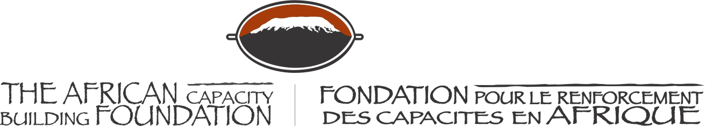

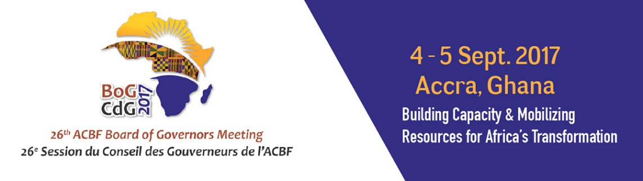

26th ANNUAL MEETING OF THE BOARD OF GOVERNORS OF THE AFRICAN CAPACITY BUILDING FOUNDATION

4-5 September 2017

MÖVENPICK AMBASSADOR HOTEL
Accra, Ghana

Welcome Remarks (Day 2: Statutory meeting)
Hon. Ken Ofori-Atta
Minister of Finance Ghana & Host Governor

The African Capacity Building Foundation: 2 Fairbairn Drive, Mount Pleasant, Harare, Zimbabwe; Tel: +2634304649.
Email: root@acbf-pact.org. Website: www.acbf-pact.org

Key messages
- As a Host, the Government of Ghana is welcoming BoG members to the statutory meeting of the 26th Annual Meeting of the Board of Governors of the African Capacity Building Foundation (ACBF).
- Highlighting to BoG colleagues on the need to reflect carefully on the importance of CD on the continent and the need to remain committed to supporting ACBF (politically and financially) as the designated specialized Agency on CD on the continent – a position conferred by Africa countries themselves through their heads of state and Government.

Honorable Goodall Gondwe, Chair of ACBF Board of Governors;
HE Erastus Mwencha, Chair of ACBF Executive Board;
Distinguished Members of the ACBF Board of Governors & Executive Board;
Prof Emmanuel Nnadozie, Executive Secretary of the ACBF
Top Government officials from Ghana;
Top Government officials from other countries;
Representatives of development partners;
Ladies and gentlemen;

Good morning and welcome once again to Accra. Specifically, welcome to the 26th statutory meeting of our Foundation (ACBF).

As it came out clearly in the high level discussions yesterday, Africa cannot achieve its developmental objectives without visionary leaders, strong institutions and capable people needed to design and implement the various dimensions of the African Union Agenda 2063 and Sustainable Development Goals (SDGs).

In this regard, ACBF as the officially designated specialized Agency on capacity development on the continent, is an important institution in the individual and collective aspirations of the countries of our Continent. ACBF has demonstrated in no uncertain terms its capacity to advance and support capacity building interventions across Africa. Its contribution to the strengthening of the institutional and human capacities as well as the socio-economic transformation of our countries through financial investments, knowledge production and sharing, and technical assistance is record breaking for such a pan-African organization.

As I pointed out yesterday, for us in Ghana, being associated with ACBF is an honour hence our readily accepting to jointly organize this board of Governors meeting in Accra.

As the BOG chair pointed out yesterday, we recognize the mammoth task that lies ahead in mobilising resources to secure the future of this great continent but we cannot afford to fail. It is our collective responsibility: African member states, multilateral and bilateral partners, Foundations, the private sector and indeed non-state actors, to mobilize the political and financial support needed to sustain the much-needed capacity development interventions.

I therefore call upon fellow Board of Governors and our development partners to put our resources where our mouth is. Let us avail to our Foundation the political and financial resources needed to enable the Secretariat to effectively implement the new strategy spanning the period 2017-2021. I can assure you that Ghana has and will continue to do its part because we believe in the Foundation and the need for coordinated capacity development on the continent.

Let us develop an Africa capable of achieving its own development.

I thank you do your attention!

Akwaaba!

Accra (Ghana)
September 5, 2017

Hon. Ken Ofori-Atta
Minister for Finance Ghana & Host Governor

