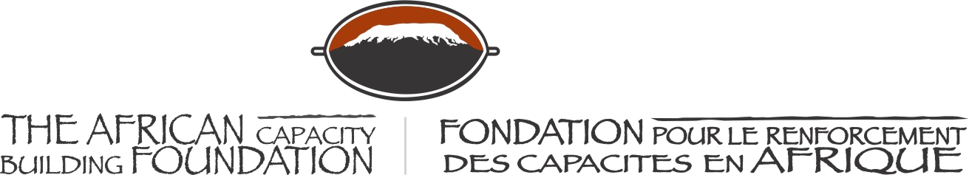

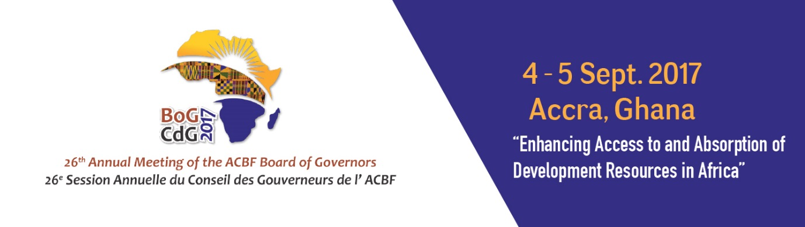

26th ANNUAL MEETING OF THE BOARD OF GOVERNORS OF THE AFRICAN CAPACITY BUILDING FOUNDATION

4-5 September 2017

MÖVENPICK AMBASSADOR HOTEL
Accra, Ghana

Welcome Remarks
Hon. Ken Ofori-Atta
Minister for Finance Ghana & Host Governor

The African Capacity Building Foundation: 2 Fairbairn Drive, Mount Pleasant, Harare, Zimbabwe; Tel: +2634304649.
Email: root@acbf-pact.org. Website: www.acbf-pact.org

Key messages
- As a Host, the Government of Ghana is welcoming all participants to the 26th Annual Meeting of the Board of Governors of the African Capacity Building Foundation (ACBF).
- Highlighting to all participants, the importance of capacity building and ACBF hence the jointly organizing of the event.

Hon. Yaw Osafo-Maafo, Senior Minister of the Republic of Ghana;
H.E. Quartey Thomas Kwesi, Deputy Chairperson of the African Union Commission;
Honorable Goodall Gondwe, Chair of ACBF Board of Governors;
Mr Erastus Mwencha, Chair of ACBF Executive Board;
Distinguished Members of the ACBF Board of Governors & Executive Board;
Prof Emmanuel Nnadozie, Executive Secretary of the ACBF
Top Government officials from Ghana;
Top Government officials from other countries;
Members of the Diplomatic Corp;
Representatives of development partners;
Distinguished panelists and experts;
Members of the media;
Dear friends;
Ladies and gentlemen;

Good morning and welcome to this beautiful city of Accra. We are honored to have you here today as we host the 26th Annual Meeting of the Board of Governors of the African Capacity Building Foundation (ACBF). My colleagues from the other ACBF Member countries and myself are especially honored to be hosting you in Accra.

It is an honor for Ghana and its people to host this Annual Meeting on the very important and timely theme “Enhancing Access to and Absorption of Development Resources in Africa” As you probably know, the choice of Accra is actually strategic on two fronts: first, Ghana is making significant strides in intensifying efforts at mobilizing domestic resources. Secondly, and on a lighter note, Accra is home to ACBF (having the regional office for West, Central and North Africa) and so we are just doing what every responsible child who is calling for a family meeting would do – she or he would do it at home.

Distinguished Ladies and gentlemen;

ACBF is an important institution in the individual and collective aspirations of the countries of our Continent as witnessed by its recognition as an African Union Specialized Technical Agency dedicated to capacity development, having demonstrated in no uncertain terms its capacity to advance and support capacity building interventions across Africa. Its contribution to the strengthening of the institutional and human capacities as well as the socio-economic transformation of our countries through financial investments, knowledge production and sharing, and technical assistance is record breaking for such a pan-African organization. Being associated with ACBF is an honor for us and hence our readily accepting to jointly organize this board of Governors meeting in Accra. Hope the next one can be held in Ghana again!

This 26th Meeting of the Board of Governors takes place following a very strategic time for Africa, given the discussions on the necessity for African countries to finance their own development (as stipulated in Agenda 2063 and Agenda 2030) and the President Kagame proposals on financing the AU. Our Continent has been surely shaken by the inadequate financing and surely the lack of knowledge in the area. This Meeting and the theme we have proposed for discussions and sharing of knowledge and experience are indeed timely and very relevant.

In connection with this, we will engage in a number of discussions over the next two days, none more important than the capacities required for the absorption of resources for development. Given the caliber, diversity and expertise as well as the enthusiasm of you all present here, I have every reason to believe that our discussions will display great outcomes and actionable proposals for the benefit of our countries and the socio-economic transformation of Africa.

Distinguished Guests, Ladies and gentlemen;

As you know, such meeting as this can also be exhausting and so I would urge you to take time off after this Board of Governors meeting to enjoy some of the amenities of our historic, beautiful and hospitable country. There is so much to see, eat and do in Accra.

I don’t want to take the thunder off the Hon. Yaw Osafo-Maafo, Senior Minister of the Republic of Ghana, so let me sit down and let him formally welcome you and open this important gathering.

Thank you very much and welcome once again.

Akwaaba!

Accra (Ghana)
September 4, 2017

Hon. Ken Ofori-Atta
Minister for Finance Ghana & Host Governor

