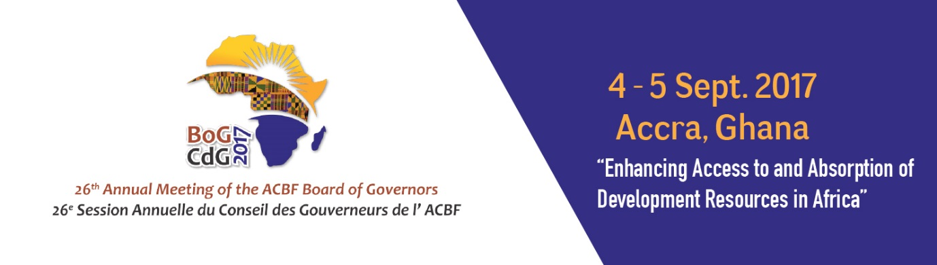

26th ANNUAL MEETING OF THE BOARD OF GOVERNORS OF THE AFRICAN CAPACITY BUILDING FOUNDATION

4-5 September 2017

MÖVENPICK AMBASSADOR HOTEL
Accra, Ghana

Chairman’s Message
Hon. Goodall Gondwe
Chair
ACBF Board of Governors

The African Capacity Building Foundation: 2 Fairbairn Drive, Mount Pleasant, Harare, Zimbabwe; Tel: +2634304649.
Email: root@acbf-pact.org. Website: www.acbf-pact.org

Key messages
- Present the important role ACBF has been playing in building capacity on the continent over the years – and hence making the case for the need for continued coordinated capacity building by ACBF especially in the context of successful implementation of Agenda 2063 and Sustainable Development Goals (SDGs).
- Urging all African Governments, development partners and the private sector to hence provide the necessary support to ACBF which has been mandated by the African Union to coordinate capacity building interventions in Africa for better development results.

Hon. Yaw Osafo-Maafo, Senior Minister of the Republic of Ghana;
H.E. Quartey Thomas Kwesi, Deputy Chairperson of the African Union Commission;
Mr Erastus Mwencha, Chair of ACBF Executive Board;
Distinguished Members of the ACBF Board of Governors & Executive Board;
Prof Emmanuel Nnadozie, Executive Secretary of the ACBF
Top Government officials from Ghana;
Top Government officials from other countries;
Members of the Diplomatic Corp;
Representatives of development partners;
Distinguished panelists and experts;
Members of the media;
Dear friends;
Ladies and gentlemen;

Good morning!

Hon. Yaw Osafo-Maafo

Let me join my ACBF colleagues that have spoken before me, to sincerely thank you very much for being here. Your presence exemplifies the importance that you give to capacity building in Africa and to ACBF as a pan-African institution.

Through you, Honorable, I extend my sincere thanks to the Government of Ghana for its cooperation, hospitality and warm welcome. This Board of Governors meeting would not have been organized without this support. We really appreciate!

Your Excellencies, Honorable Ministers, distinguished ladies and gentlemen,

In 2016 the African Capacity Building Foundation (ACBF or Foundation) celebrated 25 years of being the premiere capacity building institution on the continent.

I am pleased to report that ACBF has successfully established itself as a thought leader and reliable partner in promoting transformative change in many of our countries. The Foundation has invested in strategic engagement along the entire policy value chain and in building human and institutional capacity across Africa encompassing over 321 capacity development projects and a commitment of more than USD700 million to date.

Through its 25 years of operation, our Foundation has helped us achieve significant results in terms of increasing macroeconomic stability, fiscal management and debt sustainability; enhancing our capacity for economic policy analysis and management thanks to the training of over 50,000 economists and public sector managers as well as the creation of more than 40 think tanks and policy institutes; enhancing our accountability systems through supporting national parliaments, regional parliamentary institutions and government oversight bodies; contributing to advancing regional integration through support to the African Union and Regional Economic Communities, inter alia.

It is not surprising therefore, that at the January summit this year, the heads of State and Government officially designated ACBF as the specialised agency on capacity development.

However, despite the notable achievements, we are still confronted with persistent capacity deficits as revealed by our authoritative annual flagship publication, The Africa Capacity Report (ACR), which measures and examines capacity in relation to the development agenda in African countries. More specifically, the ACR has consistently shown over the years that capacity, more than financial resources, is the missing link and the critical impediment to effective implementation of projects and programs spelled out in continental, regional, and national development strategies. This lack of capacity explains the huge implementation gap on the continent, which has impeded even good development strategies from producing desirable development outcomes. The information gathered by the Foundation through rigorous policy-oriented research unequivocally confirms the need to intensify efforts towards building capacity on the continent in such areas as regional integration, domestic resource mobilization, natural resource management, agricultural transformation, science technology and innovation as well as transformative leadership.

Your Excellencies, Honorable Ministers, distinguished ladies and gentlemen,

The capacity challenges that we face dictate that we invest in securing the long-term sustainability of the Foundation. In this regard, I have observed that over the years there has been increased continental ownership of the Foundation by African member states. To date, ACBF has 39 African member countries. The support by African countries at the Pledging Conference in June 2016 is proof that the shareholders of the Foundation remain convinced of the continued relevance and importance of the Foundation. So let us make good of our pledges and those of us who are yet to pledge, let us do so with the sense of urgency that the capacity development agenda deserves.

Indeed, many of our countries still must enhance skills, strengthen institutions and improve their capacity to formulate, implement and evaluate effectiveness of their development policies. To achieve sustainable growth, we should promote regional integration, knowledge generation and sharing across Africa. And so let us allow ACBF which has the expertise in this area, to help us accordingly by giving it all the required political and financial support.

We note that success and growth on the continent is very differentiated. In such circumstances, it is incumbent upon us to align interventions with the continental development priorities including looking at the special needs of conflict and crisis affected countries. Supporting these countries in achieving tangible development results will make significant contribution in closing the gap between the rich and the poor – a goal that is at the centre of the new ACBF Strategy (2017-2021) which this Board approved last year. This effort requires collective action. To this end, we must go beyond the traditional development partners and harness private sector and civil society contributions in supporting inclusive economic development while leveraging knowledge and learning to increase development effectiveness.

We recognise the mammoth task that lies ahead in mobilising resources to secure the future of this great continent but we cannot afford to fail. It is our collective responsibility: African member states, multilateral and bilateral partners, Foundations, the private sector and indeed non-state actors, to mobilize the political and financial support needed to sustain the much-needed capacity development interventions.
I therefore call upon leaders in Africa to set the tone by availing the financial resources needed to enable the Secretariat to effectively implement the new strategy. In line with what was agreed at the Board of Governors meeting held in Libreville in June 2013, we need to be able to mobilise resources to cover all the institutional costs of the Foundation while inviting our development partners to join us in funding the programmatic activities.

Your Excellencies, Honorable Ministers, distinguished ladies and gentlemen,

Let me conclude by restating my appeal for action in intensifying political and financial support for the Foundation. Africa cannot achieve its developmental objectives without visionary leaders, strong institutions and capable people needed to design and implement the various dimensions of the African Union Agenda 2063 and Sustainable Development Goals (SDGs).

ACBF is the central cog in unlocking the unrealised potential in many of our countries. It is now time for action, let us support ACBF support our efforts in bringing about sustainable growth on the African continent.

Let us build an Africa capable of achieving its own development!

Thank you for your kind attention.

Accra (Ghana)
September 4, 2017

Hon. Goodall Gondwe
Chair
ACBF Board of Governors

