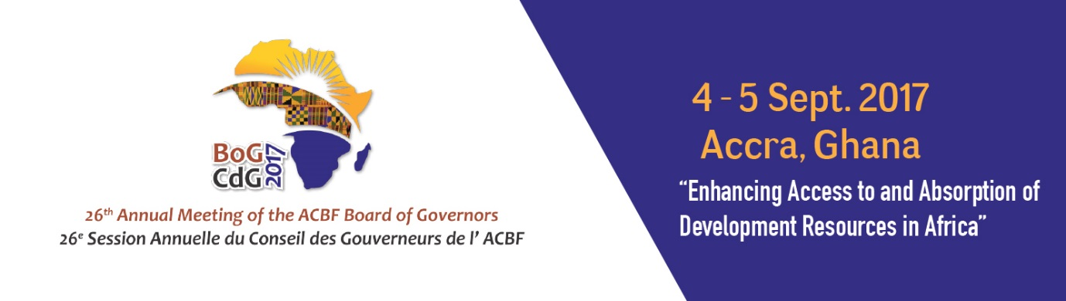

26th ANNUAL MEETING OF THE BOARD OF GOVERNORS OF THE AFRICAN CAPACITY BUILDING FOUNDATION

4-5 September 2017

MÖVENPICK AMBASSADOR HOTEL
Accra, Ghana

Remarks
Mr Erastus Mwencha
Chair
ACBF Executive Board

The African Capacity Building Foundation: 2 Fairbairn Drive, Mount Pleasant, Harare, Zimbabwe; Tel: +2634304649.
Email: root@acbf-pact.org. Website: www.acbf-pact.org

Key messages
- Extending a vote of thanks to Government of Ghana and its leadership for joint organization of the event.
- Highlighting some of the ACBF achievements especially in 2017 and calling for continued political commitment and increased financial support towards ACBF’s interventions especially the 2017-2021 Strategy.

Hon. Yaw Osafo-Maafo, Senior Minister of the Republic of Ghana;
H.E. Quartey Thomas Kwesi, Deputy Chairperson of the African Union Commission;
Honorable Goodall Gondwe, Chair of ACBF Board of Governors;
Distinguished Members of the ACBF Board of Governors & Executive Board;
Top Government officials from Ghana;
Top Government officials from other countries;
Members of the Diplomatic Corp;
Representatives of development partners;
Distinguished panelists and experts;
Members of the media;
Dear friends;
Ladies and gentlemen;

A very good morning to all!

Allow me to join Prof Nnadozie, the ACBF Executive Secretary, in expressing gratitude to Hon. Yaw Osafo-Maafo, Senior Minister of the Republic of Ghana for his presence this morning. ACBF is indeed very grateful the leadership of the Republic of Ghana for the joint organization of the 26th Annual Meeting of the Board of Governors of the African Capacity Building Foundation (ACBF). Beyond this, the political and financial support of Ghana to ACBF has remained unwavering throughout the years.

On behalf of the Executive Board of ACBF, I would also like to sincerely congratulate, Honourable Goodall Gondwe, Chair of ACBF Board of Governors and the ACBF secretariat for successfully organizing this important statutory meeting of the Foundation.

Distinguished delegates, ladies and gentlemen;

As a statutory annual gathering, this meeting will serve as a platform to report on key achievements of ACBF to the Board of Governors and also to reflect on strategic issues relevant to Africa’s development especially those related to capacity development. Since 1991, ACBF as a continental body, has been fulfilling its mandate to ensure that capacities are in place at all levels to deliver the expected development results.

A lot has been achieved and we will be sharing more insights on the achievements tomorrow. The satisfactory results notwithstanding, there is still much to do as the continent has embarked now on the implementation of the Agenda 2063 and the Sustainable Development Goals – ACBF has already proactively published a number of studies to guide the continent on the capacity required and the strategies for addressing the gaps.

By way of example, in 2016, the Foundation has supported the African Union in mapping the capacity imperatives for the realization of Agenda 2063’s vision of “building an integrated, prosperous and peaceful Africa, driven and managed by its own citizens representing a dynamic force in the global arena” and has done the same exercise for the Agenda 2030.

In recognition of this tremendous contribution to Africa’s development and the relevance of ACBF mandate, African leaders have this year officially designated ACBF as the African Union’s specialized agency for capacity development. This recognition launches the beginning of a new era for capacity building by ACBF which will require an appropriate level of political commitment and financial support. I thank African governments and development partners for their support and take the occasion to emphasize the need for continued financial support to ACBF.

As you all know, implementation is the main challenge for African countries. We have always been able to devise well-thought out plans and strategies but continue to fail at the implementation level. That is why I found the topic of this Board of Governors meeting “Enhancing Access to and Absorption of Development Resources in Africa” very relevant and timely for the continent. Implementation of development plans requires appropriate level of resource mobilization but equally important is the need to pay attention to the capacities for absorbing them. There is strong evidence that in addition to the challenge of mobilizing resources especially domestic resources, African countries do not have the capacity to effectively allocate and absorb the resources being made by development partners towards economically and socially productive activities.

Your Excellencies, Distinguished Delegates;

Africa needs ACBF to continue playing its capacity building coordination role to effectively address development bottlenecks such as the limited absorptive capacity. The Foundation is well placed for this role on the continent not only because it has accumulated immense experience and knowledge on capacity development but also because the growing impact of its operations and interventions provides the proof that capacity should be central to development.

For more than two decades, the Foundation has reinforced public policy formulation and implementation, trained highly qualified economists and public servants and created more than 40 think tanks. ACBF has also supported the institutional transformation processes of the African Union Commission and provided targeted capacity building support to facilitate the implementation of the priority thematic programs of the Commission approved by the policy organs of the African Union. Moreover, ACBF has also supported regional integration projects and Regional Economic Communities (such as COMESA, EAC, ECOWAS, IGAD, and SADC,) which enhanced the capacity of the institutions to promote stronger economic and political collaboration among the countries and implementation of the continental and regional strategies. These have yielded tangible results with the Africa Capacity Report, the Foundation’s annual flagship publication, highlighting that most countries having moved up over the years – thanks to ACBF and cooperating partners – from low capacity to medium capacity levels.

Moving forward, the Foundation has through wide consultations, devised its 2017-2021 Strategy which has four important pillars: enabling effective delivery of continental development priorities such as Agenda 2063; supporting countries to achieve tangible development results;, enhancing the ability of the private sector and civil society to contribute to sustainable development and; leveraging knowledge and learning to increase development effectiveness.

For this strategy to deliver on the expected results, it requires the continued commitment and financial support of African Government and cooperating partners. By designating ACBF as the specialised Agency n capacity development, the African Union leadership is simply voicing the voice of the Africa people that coordinated capacity development should be a priority moving forward and we count on you Governors and cooperating partners in this noble agenda.

Distinguished delegates, ladies and gentlemen;

I would like to conclude by thanking once again the Government of Ghana, its leadership and Hon. Yaw Osafo-Maafo for supporting this important meeting. I would also like to sincerely thank all the delegates from Africa and abroad for joining us today. It is both gratifying and truly humbling for the African Capacity Building Foundation to witness this overwhelming support exemplified by your presence today.

Together, we can and should build an Africa capable of achieving its own development.

Thanks for your attention!

Accra (Ghana)
September 4, 2017

Mr Erastus Mwencha
Chair
ACBF Executive Board

