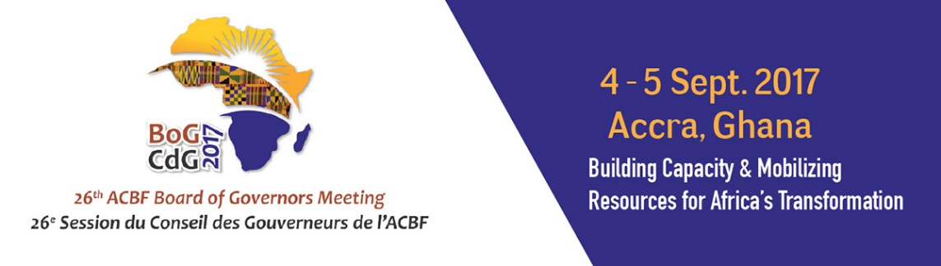

26th ANNUAL MEETING OF THE BOARD OF GOVERNORS OF THE AFRICAN CAPACITY BUILDING FOUNDATION (ACBF)

4-5 September 2017

MÖVENPICK AMBASSADOR HOTEL
Accra, Ghana

Introductory remarks
Prof Emmanuel Nnadozie
Executive Secretary
The African Capacity Building Foundation

The African Capacity Building Foundation: 2 Fairbairn Drive, Mount Pleasant, Harare, Zimbabwe; Tel: +2634304649.
Email: root@acbf-pact.org. Website: www.acbf-pact.org

Key messages
- Introduce the main aim of the 26th BOG Meeting: (i) share the lessons and country experiences related to capacities for resource utilization and absorption – encouraging ministers and development partners to actively participate so as to identify innovative capacity development approaches in this area; and (ii) hold the Regular Session of the Board of Governors Meeting of ACBF.
- Bring to the attention of the BoG, the significance of this meeting – marks the time when the Foundation has started to implement the new Strategy (2017-2021). Highlighting therefore, the secretariat’s commitment to deliver and the need for BoG’s political and financial support as well of cooperating partners, for the Strategy to be realised.

Hon. Yaw Osafo-Maafo, Senior Minister, Republic of Ghana;
H.E. Quartey Thomas Kwesi, Deputy Chairperson of the African Union Commission;
Honorable Goodall Gondwe, Chair of ACBF Board of Governors;
Hon. Ken Ofori-Atta, Minister for Finance Ghana
Mr. Erastus Mwencha, Chair of ACBF Executive Board;
Distinguished Members of the ACBF Board of Governors & Executive Board;
Top Government officials from Ghana;
Top Government officials from other countries;
Members of the Diplomatic Corp;
Representatives of development partners;
Distinguished panelists and experts;
Members of the media;
Dear friends;
Ladies and gentlemen;

Good morning!

Your Excellency,
Allow me to sincerely thank you for taking time off your busy schedules to come and officially open this 26th Annual Meeting of the Board of Governors of the African Capacity Building Foundation (ACBF) which has been jointly organised with the Government of Ghana. ACBF is very grateful to the authorities of Ghana for hosting us in this wonderful city of Accra which is also Headquarters to our regional office for West, Central and North Africa. The political and logistical support, not just for this meeting but over years, has been outstanding.

Distinguished Ladies and Gentlemen,
It is a great honour and pleasure for me to extend a warm welcome to you all. I would like to express my sincere gratitude for your making it to this very important meeting. Your presence is sincerely appreciated and is a true reflection of the common vision that we share – that of building an Africa capable of achieving its own development.

The aim during the coming two days is mainly to (1) share the lessons and country experiences related to capacities for resource utilization and absorption; and (2) hold the regular session of the Board of Governors Meeting of ACBF where Governors will get an update on interventions by the Foundation on the continent in 2016 and the priorities of the next five years as defined in our 2017-2021 Strategy.

Distinguished ladies and Gentlemen;
The theme of this year’s Board of Governors’ meeting on “Accessing funds for development: required capacities for resource mobilization, utilization and absorption” is critical for implementation of Agenda 2063, Sustainable Development Goals (SDGs) as well as regional and national development plans.

As you will also know, the ACBF’s Board of Governors, did request the Foundation to focus its 2015 flagship publication (the Africa Capacity Report) on capacity imperatives for domestic resource mobilization. And indeed the 2015 Africa Capacity Report sends a very clear message: with official development assistance to Africa diminishing, the continent will have to rely more on mobilizing domestic resources if it is to move forward on meeting both the Agenda 2063 and the Sustainable Development Goals.

Further, the Foundation has discovered that it has become urgent that we go beyond addressing the resource access challenge towards finding solutions to the utilization and absorption of resources challenge. There is a compelling body of knowledge pointing to limited absorptive capacity as a key impediment to the implementation and effectiveness of various development projects and programs in Africa.
Th secretariat is ready to play its part in tackling the capacity challenges for addressing these issues. More than ever before, the role of coordinating this capacity development mandate on the continent is more compelling now with the official status confered on us by the African Union this year, of a specialized agency on capacity development. But as you will all agree, for us to effectively deliver on this mandate, we will need the political and financial support of African Governments and cooperating partners. We can have no better ambassadors for this than the Board of Governors and the various development partners represented here.

We are therefore looking forward to receiving your invaluable individual and collective contributions to the important discussions and sessions we will be having today and tomorrow on these pertinent issues. And more importantly, your political and financial commitment to support the cause of building an Africa capable of achieving its own development.

Thank you very much for your attention.

Prof Emmanuel Nnadozie
Executive Secretary
The African Capacity Building Foundation
September 4, 2017

